**Drone-Based Traffic Surveillance System**

# 

# Submitted to:

Dr. Muhammad Aslam

# Submitted by:

* Hamza Farooq 2020-MSCS-513
* Komal Shehzadi 2020-MSCS-590





# Introduction:

Drones, i.e., small unmanned aerial vehicles (UAVs), are experiencing explosive growth nowadays and they have been widely used in many areas, e.g., aerial photography, traffic monitoring, disaster monitoring, etc. They have attracted many research interests with regard to path planning, secure communication, attack detection, and so on.

Drone net architecture is used in many crucial environments such as traffic surveillance. In traffic surveillance multiple factors can be analyzed which are based on drones.

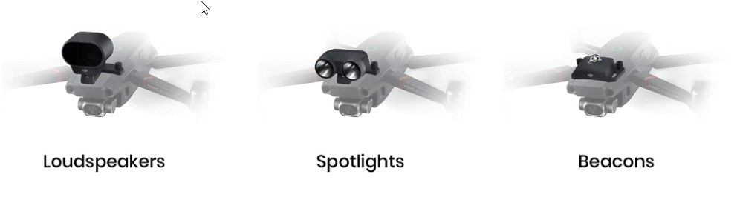

Given the recent circumstances there are numerous advantages of drone-based surveillance and traffic surveillance is also one of them.

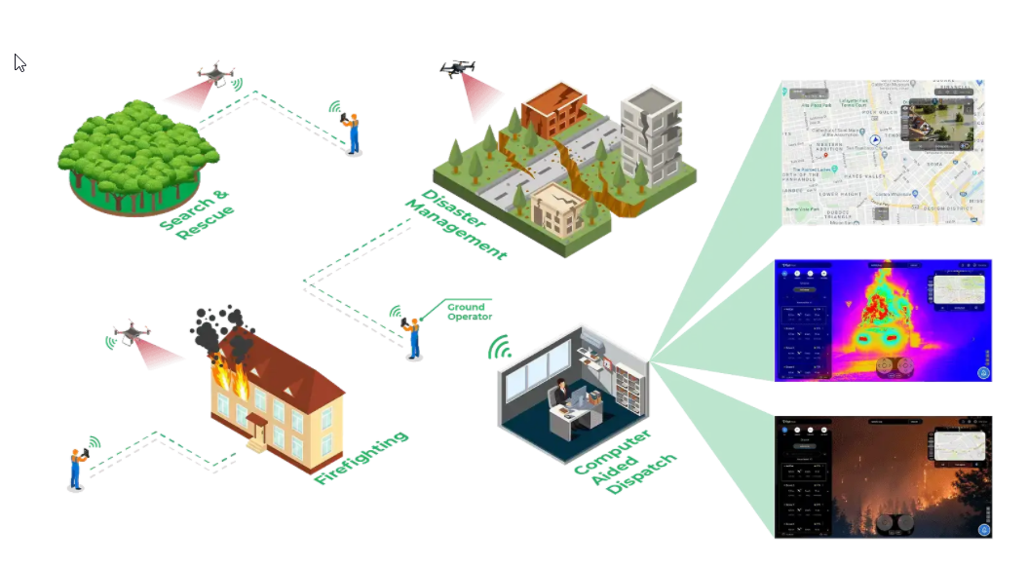

# **Why Use Drones for Highway Patrolling**

With regards to highway patrolling, drones provide the following advantages:

* A drone can reach a location much faster compared to ground-based vehicles, which is why they are ideal for the role of first responders.
* In situations like wildfires or avalanches, where roads get blocked, drones can be sent to assess the situation and identify people who are in distress.
* Drones can help optimize the resources to be deployed for emergency response, by providing crucial first-hand information on a fast-evolving situation to human first responders (police, fire, and paramedic).
* Drones can carry a variety of payloads, such as Automated External Defibrillators. A drone carrying an AED can save lives by rapidly reaching someone having a cardiac arrest in remote areas.

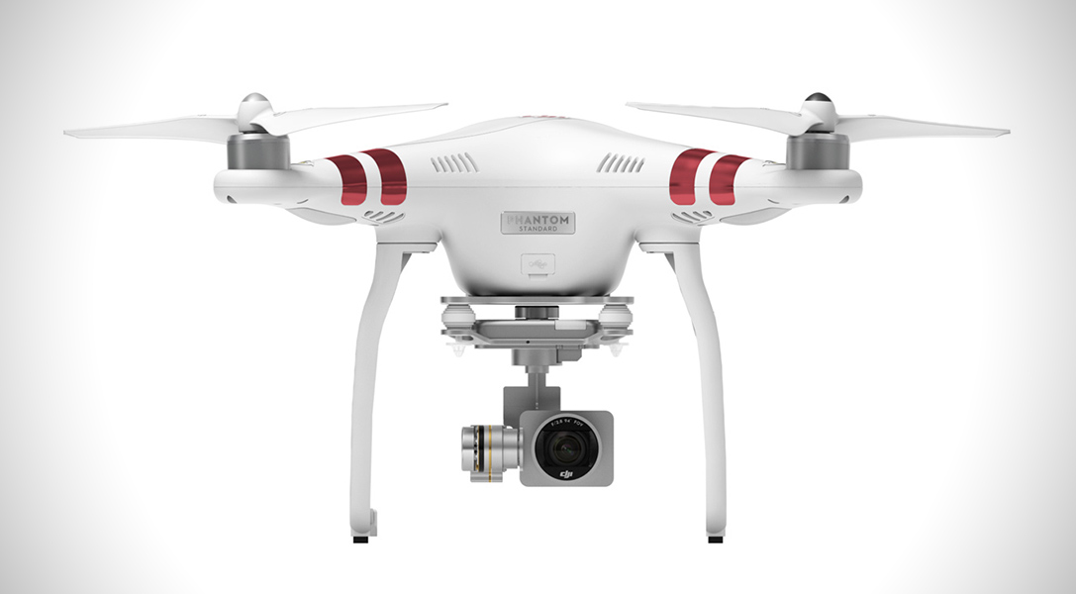

# Environment Factors:

Environment factors shows which type of circumstances will be available in real time since traffic surveillance depicts direct interaction of drone agent with environment so it is crucial to discuss these factors earlier. Drones are expert systems they can take smart decisions based on the domain they are placed.

* Inaccessible
* non-deterministic
* non-episodic
* dynamic
* continuous

In real time environment the dynamic and complex nature is difficult to deal so it requires more analyses on how to deal with certain environments.

# Intentional System

It is also an intentional system as per definition by McCarthy:

‘To ascribe *beliefs*, *free will*, *intentions*, *consciousness*, *abilities*, or *wants* to a machine is *legitimate* when such an ascription expresses the same information about the machine that it expresses about a person. It is *useful* when the ascription helps us understand the structure of the machine, its past or future behavior, or how to repair or improve it. It is perhaps never *logically required* even for humans, but expressing reasonably briefly what is actually known about the state of the machine in a particular situation may require mental qualities or qualities isomorphic to them. Theories of belief, knowledge and wanting can be constructed for machines in a simpler setting than for humans, and later applied to humans. Ascription of mental qualities is *most straightforward* for machines of known structure such as thermostats and computer operating systems, but is *most useful* when applied to entities whose structure is incompletely known’.

Intentional Systems provide a layer of abstraction to represent objects and actions which is important to create an abstract architecture.

# Abstract Architecture

The architecture of drone-based traffic surveillance system can be described by these points we will be referring to the system as an agent since it is adaptable according to its environment:

* In a real time, environment, environment can be any state which resides within environment factors for example if we particularly consider highways for traffic surveillance then the environment states will be all possible conditions on a highway considering the weather and all other factors which can change the environment state.



E contains all the environment on a highway during surveillance for example a smooth road with sunny weather and then with slightly drizzly weather and the drone will take actions accordingly since the environment also dependent on vehicles in this case then drone will keep track of all the states of vehicles so there are infinitely states a drone can encounter in a highway traffic surveillance that’s why it’s a expert system it learns from its knowledge whenever a new environment comes we can simply program it to act accordingly and it will follow that in future as well. We will take example of a car which is crossing speed limit in normal weather condition and continue to see how it will work.

* Secondly, there are all available actions for an agent in a certain condition. For each environment there are a set of available actions.



Here all the actions are available in Ac in our example for high speed car drone can take the picture of the car and flash some light on it so the owner might know that he has been fined for some traffic violation.

* Lastly, there is a sequence created by these environments and actions which can be considered as the run of agent. By encountering environment E1 agent performed action Ac1 and went to Environment E2.

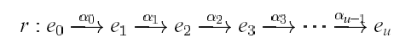

In our example agent encountered a speed limit crossing car on highway and took a picture of its plate then charged its fine and flashed a light this can be considered as the run of agent.

# State Transformation Function:

In our system the initial state is defined which is e0 and set of Environment E is given and τ is transformation function it represents the behavior of the agent.



we say an environment *Env* is a triple *Env* =〈*E*, *e0*, τ〉 where: *E* is a set of environment states, *e0∈ E* is the initial state, and τ is a state transformer function.

In proposed system whenever drone encounters an environment it will act by passing its state to state transformation function so that the suitable action can be performed.

Agent plans about what action to perform based on the history of the system that it has witnessed to date. Let AG be the agent



It maps the run to its action for example the complete run requires some actions to be performed which will be decided by agent.

It’s a perception system it sees its environment and perform action which changes the environment and the flow continues:

For example, how a human depicts environment by it perception so if an agent does the same it is considered as perception system.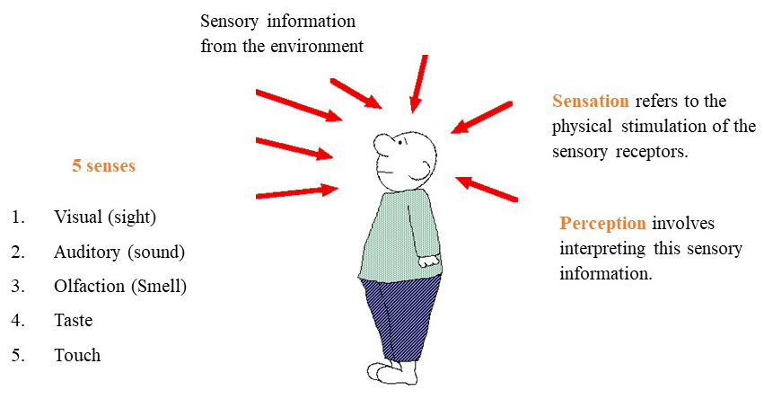

The action of agent is based on environment visibility.

The *see* function is the agent’s ability to observe its environment, whereas the *action* function represents the agent’s decision-making process *Output* of the *see* function is a *percept*:

**see: E → Per**

which maps environment states to percepts, and *action* is now a function

**action: Per* → A**

which maps sequences of percepts to actions

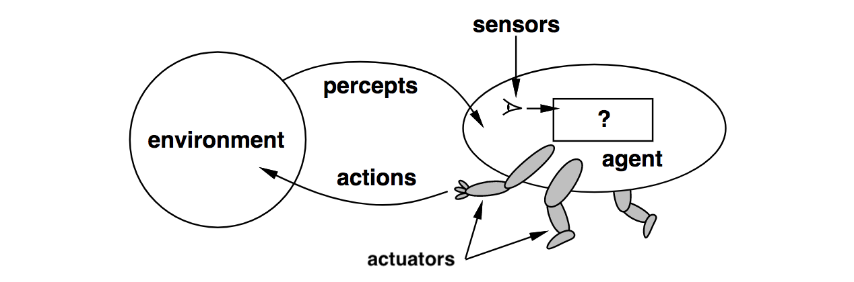

Since it’s a traffic surveillance system its utility will be increased as much as it keeps track of all the vehicles following traffic rules. Its utility factor is not considered more crucial as in gaming environments.

# Synthetic Agent:

The proposed system can also work as synthetic agent. It can create an agent based on given environment so it can complete the goal.

In fact, it better to make it a synthetic agent given the rules it can always give an agent which can complete actions

Given this:



And complete the action if: 

# Pseudo Code:

The flow of the agent actions will be like this:

* Since it is a synthetic agent It will take all the environment features as a parameter and create an agent to fulfill the task.
* The agent will take all the factors like environment, road condition, weather condition, vehicle condition in regular intervals of time.
* Then, based on factors it will decide whether the conditions are normal or not.
* If they are normal it will simply move towards next features.
* If there is something abnormal it will generate an agent will complete the tasks to validate the traffic rules in a road.
* After performing action, it will again resume its state.

# Control Loop:

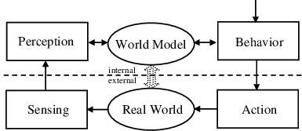

# Deductive Reasoning Agent:

for each *frame* ∈ *video stream* do

if frame is changed and vehicle is found |ρ *Check if speed limit exceeds* then

return *printout a challan for speed crossing and flash light on vehicle*

end-if

if frame is changed and vehicle is found |ρ  *Check fake plate* then

return *blow high pitch horn to alert police*

end-if

end-for

return *null*

*Ac = {check speed limit, check fake plate, print challan, flash light, blow horn}*

Ac contains all the available actions for the agent which will be performed in each suitable condition.